**MODULE ANALYSIS**

**Date:15/11/2023**

**Aim:** Analysing Circulation module, Publishing Module, Payment Module, Chat Module, GIS implementation

**Module 2: Todo List Module**

* This module enables the user to create, modify and remove tasks.
* The module will moreover permit the users to Set due dates and categories.
* The user can mark tasks as completed or incomplete.
* The user has the advantage of filtering and sorting tasks based on different criteria.

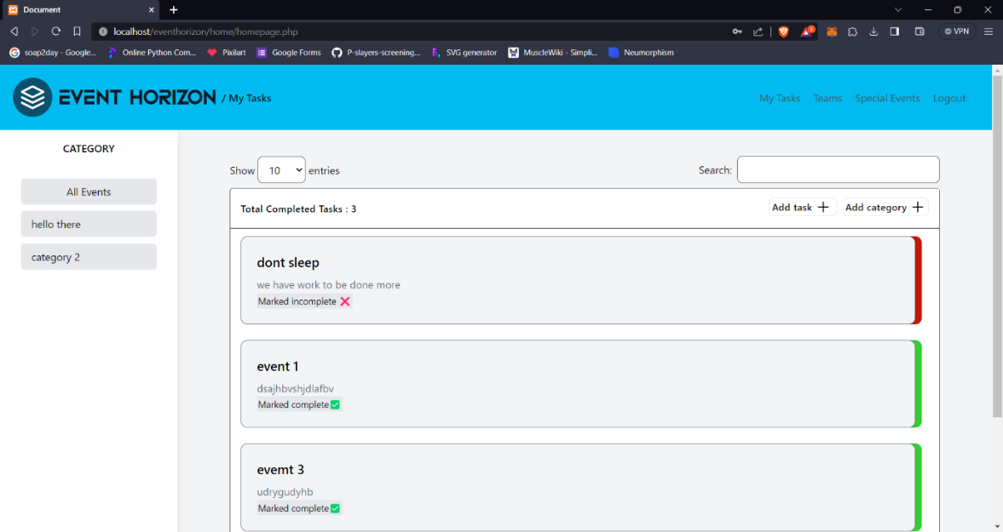

* 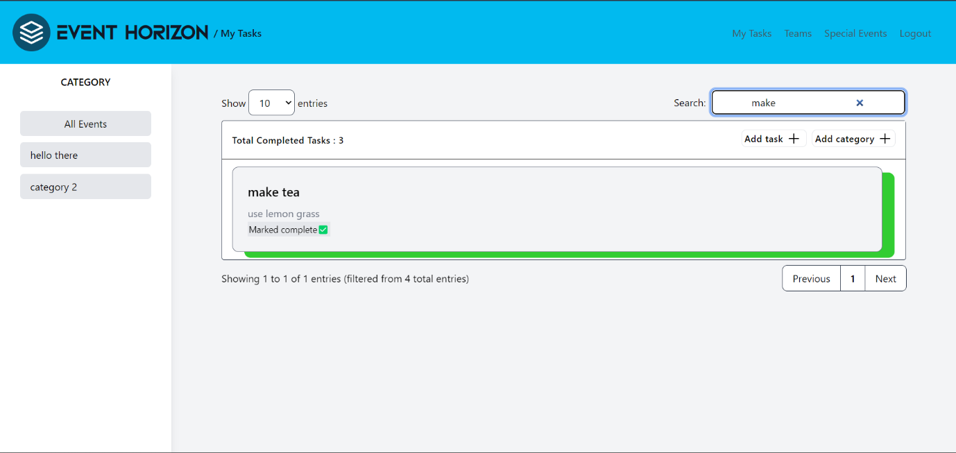Search Option
* Sort by Categories

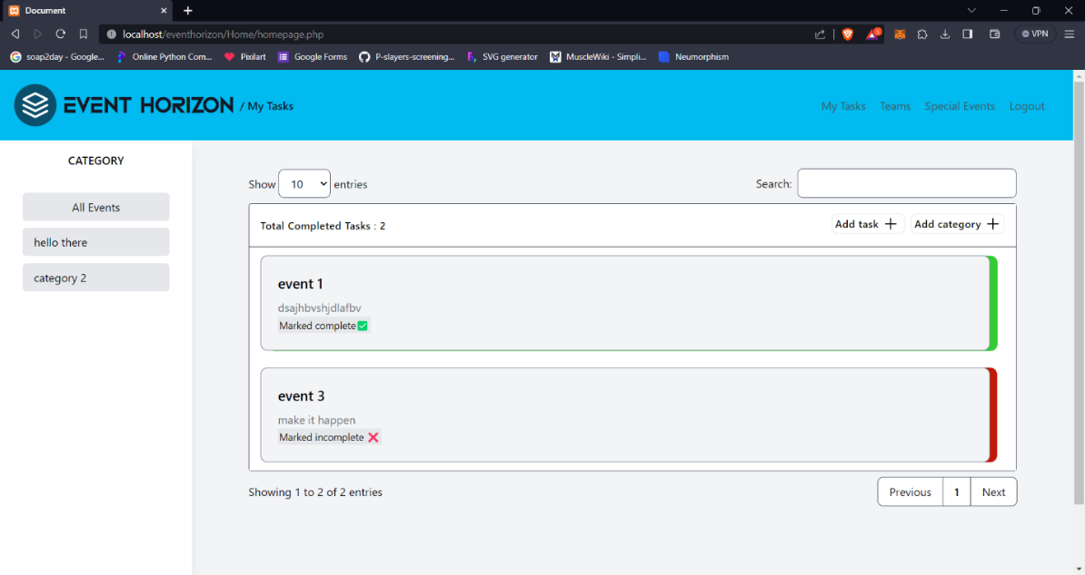

* Category Creation

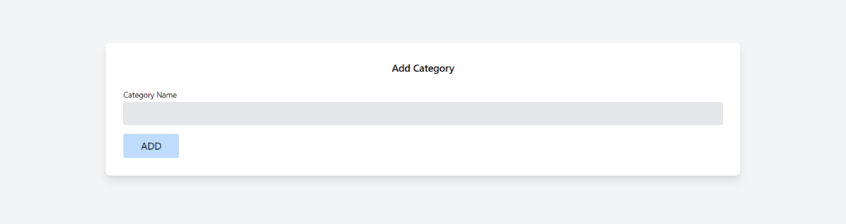

* Event Creation

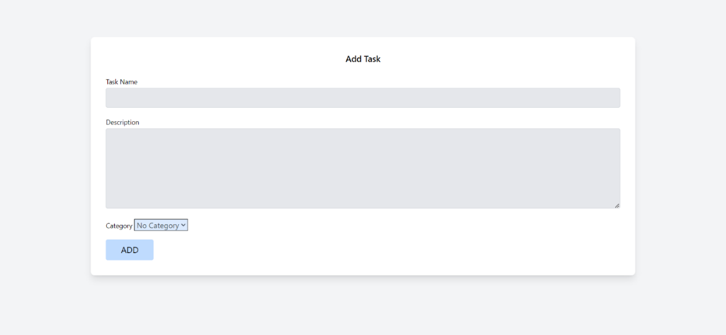

* Clicking on the provided action buttons the mentioned actions can be taken
* 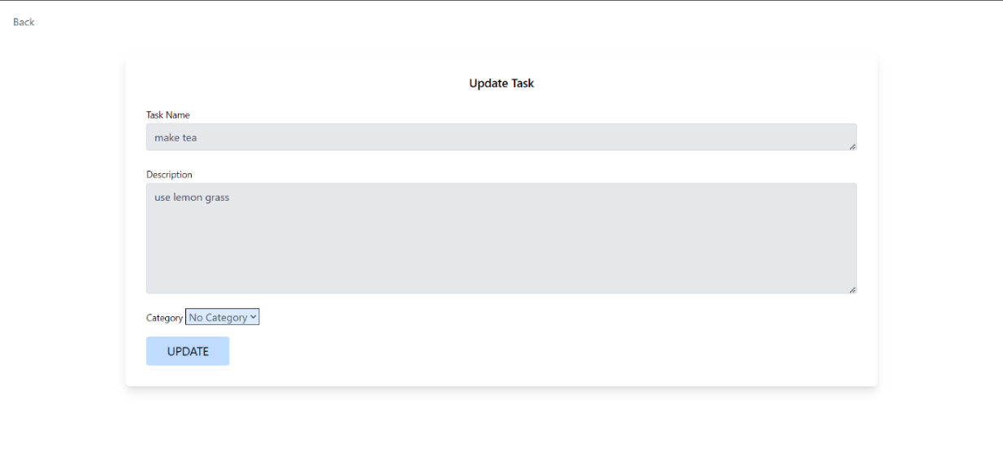Edit Task
* Data base for the stored events and tasks:

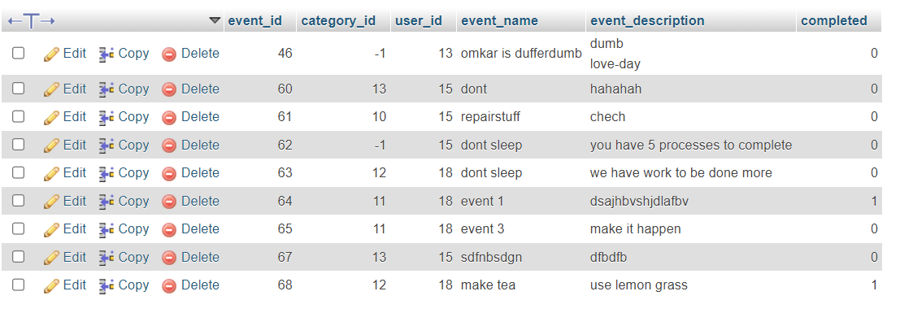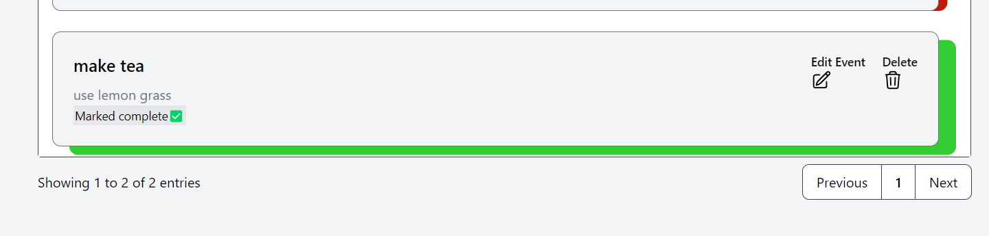

**Module 3: Event Management Module**

* The Event Management Module allows the user to create and manage special events.
* The organizer can specify event details like date, time, location, and description.
* These events are visible globally to all users.
* 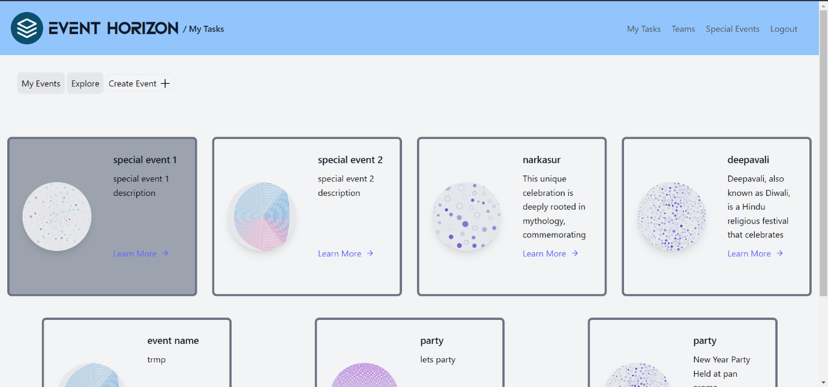Users can enrol to the global events.
* Special Event Creation

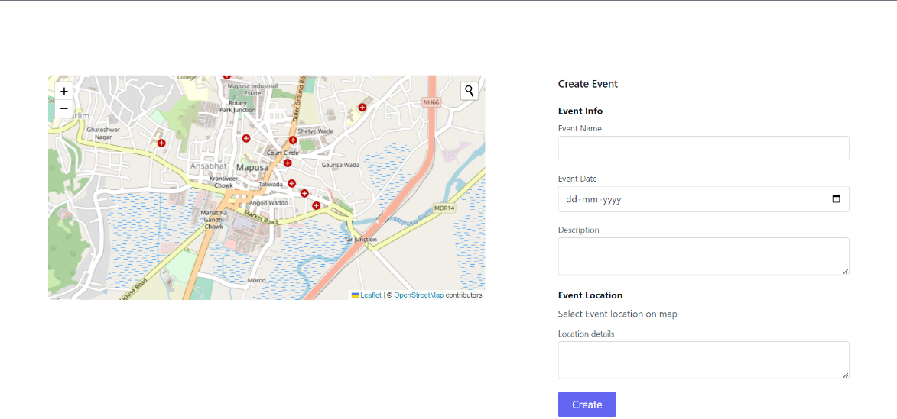

* A special event display

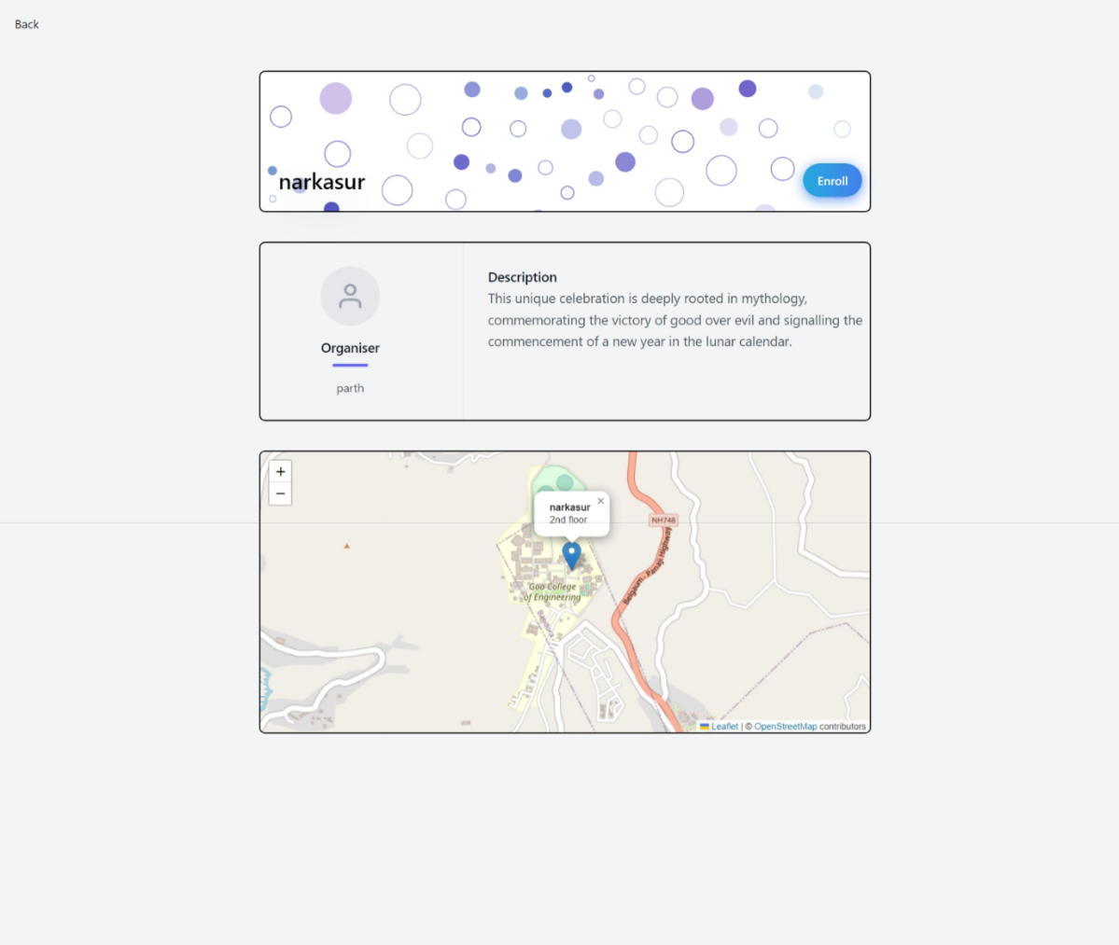

* 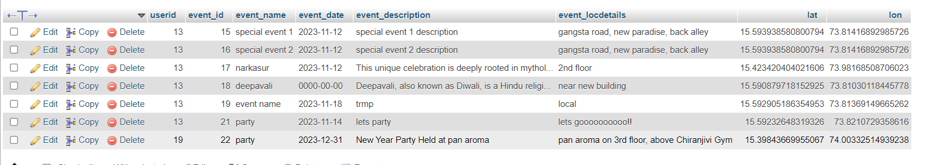Special Event Database

**Module 4: Collaboration**

* This module allows the user to share tasks and events with other users.
* The user has an advantage of creating collaborative task lists or shared calendars to manage tasks for teams.
* 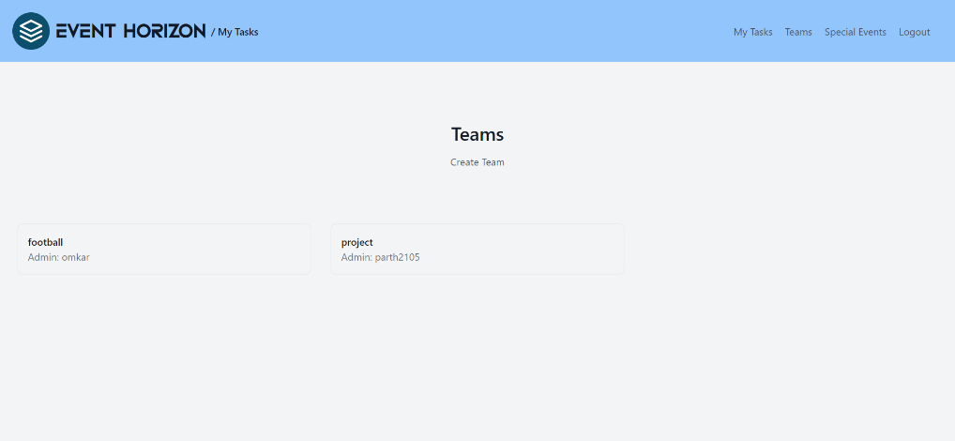The layout clearly shows the participant list, tasks and buttons to add and remove participants.
* 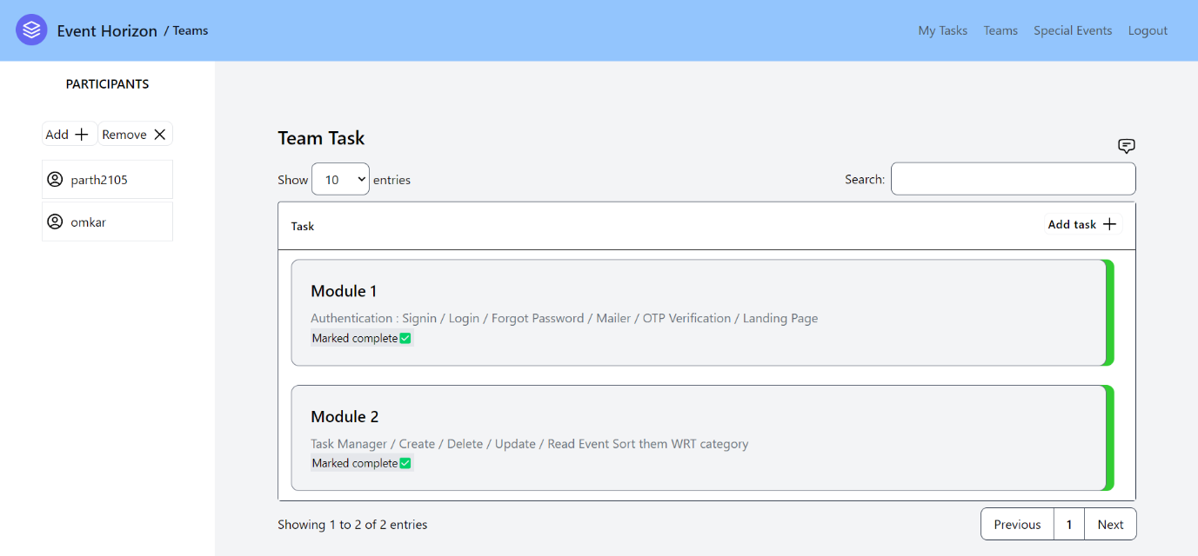The admin of the team is the only person authorized to add and remove participants.
* Chat Module
  + 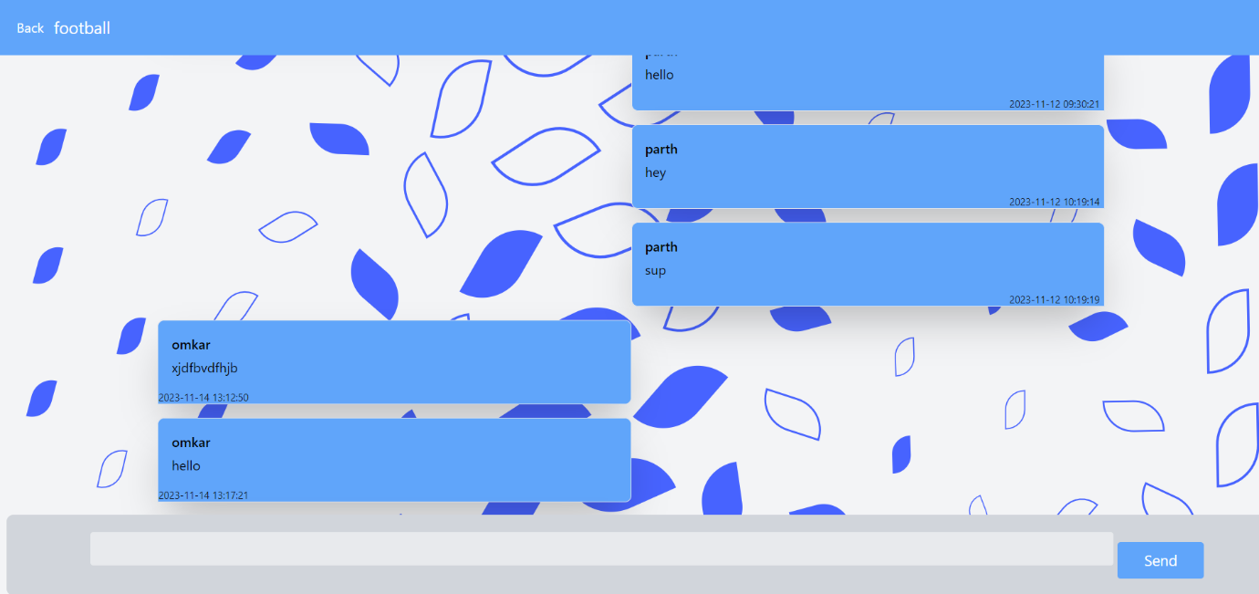Allows the team members to have a conversation for better collaboration.
* 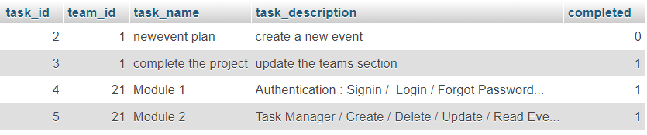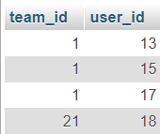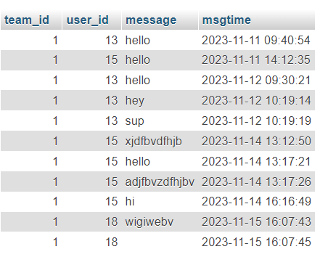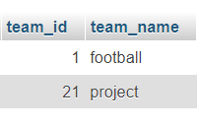Data Base For Teams and Chat Module

**Conclusion**: All the required modules were implemented successfully.